Chapter # 5: Discussion & Conclusion

Student : Ramman

Title: ERP System For Institutes

# Chapter # 5 Discussion & Conclusion

Python application works efficiently due to its ability of integrated online libraries, enterprise resource planning application organized and manage the educational resources. Python flask which is web framewrok to process the resource planning task to support educational requirement to executes resources on web based application. Previous ERP was very complex and not accurately works well, due to lack of educational requirments hence oracle database applications which is more complex to organize the systematic task. Online open ERP system is not match the educational resource planning requirement which is not working well. Beside this Amazon, ORACLE, Azure, IBM cloud providing cloud based online enterprise solution which is much costly and which does not meet the student and faculty requirement to process the educational needs. Since overall educational resources system change their requirement on frequent time which adds more complexity and complex features, so enterprise solution changing & modification permitted in order to increase the criteria.

Python programing is light weight and good GUI interface which has less coding features compartive to Java, C# ASP, C++ etc. It is suggested and recommended by various programmar and researcher that python programming is more supportive than any other of that, so the interface of flask web which needs only installable library packages to process the web application into web browswer. The limitation is very vast and appealing the criteria of resources which enhance the featured application to be processed and updated according to the given requirement.

(Costa, C. and Aparicio, M., 2006) organizational tools in the web open ERP solution which support online web based organization resource planning hence ERP solution is open source planning solution which support in many fields that has integrated with different tools & technique, since large number of organization does not afford costly ERP solution which has limited resource to organized and mange employees and customer records. Since open source ERP solution which is not free of cost but some modules might be available freely to use them but limited capacity.

## Comparative Discussion of Open Source ERP Software

(Bajaj, S. and Ojha, S., 2016) in today worlds ERP system is much complex to meet the business needs since ERP solution is solution to solves all business needs which has integrated on various business functions. ERP solution which support small and medium enterprises organization, ERP5 is fully featured open source online ERP solution which meets the business requirement which providing the industry solution with more than 300 employees in 5 different global cities. Common functions of ERP5 is as follows:

1. CRM customer relationship management
2. Product Data Management
3. Manufacturing requirement planning
4. HRM
5. E-Commerce

### TINY ERP (OPEN ERP)

Tiny ERP is known as open source ERP solution which are available on desktop edition and android mobile edition to support different kinds of problem, the architecture and styles of TinyERP is like open ERP solution constructed like SQL database functions.

### SQL ledger

SQL ledger is web based ERP solution system which executes on windows operating system and Mac system which support small size and micro size organization functionality. Hence the entire system of SQL ledger which linked through the chart like inventory and accounts functionality mostly support finance application in common.

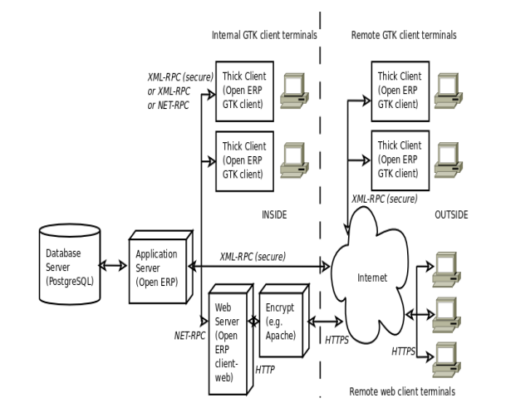

Figure: Architecture of OPEN ERP

## Automated Software Architecture Security Risk Analysis

(Almorsy, M., Grundy, J. and Ibrahim, A.S., 2013) reviewing the literature which suggest some comprehensive solution to meets the desired requirement according to the functionality of system development hence the software development life cycle needs security life cycle to secure the internal file system of ERP software. Since object constraint language (OCL) which uses the signature to target the system to locate signature matches and capture the internal data of the system and spoil them in bad manner. Since NIST security principle which attacked on database system based on CAPEC, so needs to improve them in order to run the software more appropriate manner.

## OPEN SOURCE ERP to Support Chicken Meat Processing Company

(Vanany, I., Maftuhah, D.I., Soeprijanto, A. and Zulhafizh, M., 2019) the objectives of this research to produces the best quality halal meat and distribute them in which the requirement is occurred, OPEN source ERP solution is best way to organize these types of system. Chicken Meat Company is used as case studies of this research to identify the processing of ERP software hence the large amounts of target subsidiaries system needs efficient data processing system to support customer in online. To model the database relationship using the use case diagram of software which ensures the number of target process in OPEN source ERP software, the solution considered to process payment transactions online in best predicted manner which has valid reason.

## Effective ERP Solution based on Case Studies

(Grobler-Debska, K., Żak, B., Baranowski, J., Kucharska, E. and Domagala, A., 2021) ERP solution composed of decision making solution which process customer, handle product manufacturing process which also suggest solution based on different complexity. Hence the application of POLISH company which uses the mass customization pharmacy industry to process medication requirement.

## Recommendation & Solution

It has suggested and recommended from various previous researches that OPEN source ERP solution which support only industrial application such as small and medium organization. Since large organization required customized ERP solution based on real python programming which meet the requirement. OPEN source ERP solution which does not meet the educational requirement in real situation. Python Flask application is best choice to predict and analyze the student problem to model educational resources in more effective way.

Python and MYSQL database system works very well to organize the MSc program enterprise resource planning applications. It has been suggested that the applications is good to used and easily configure and manageable.